DROP DOWN LIST

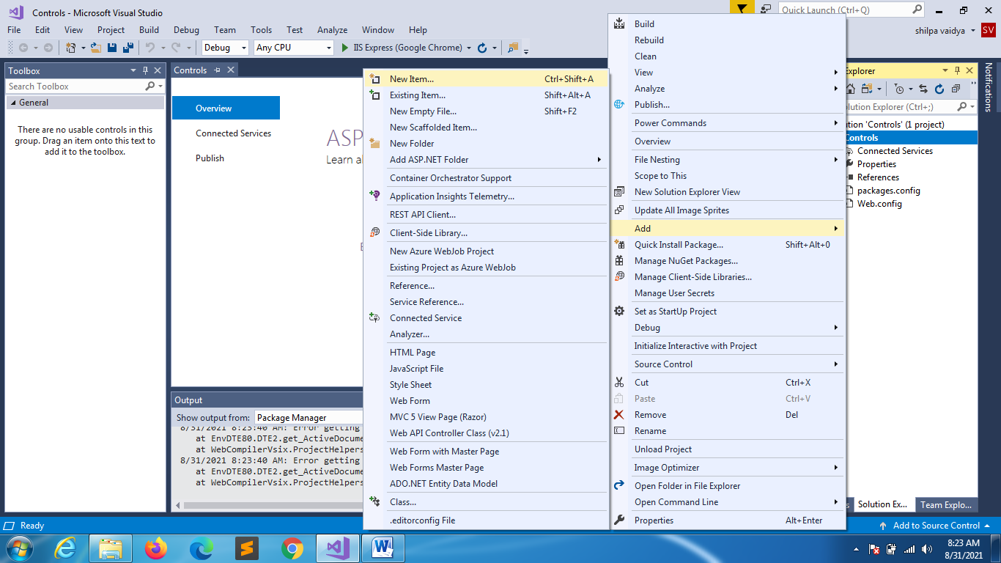

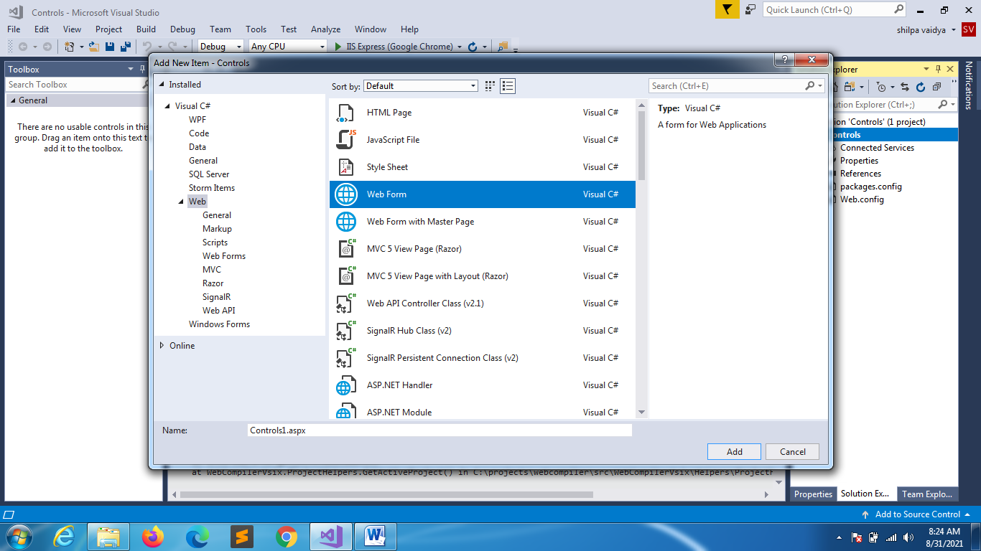

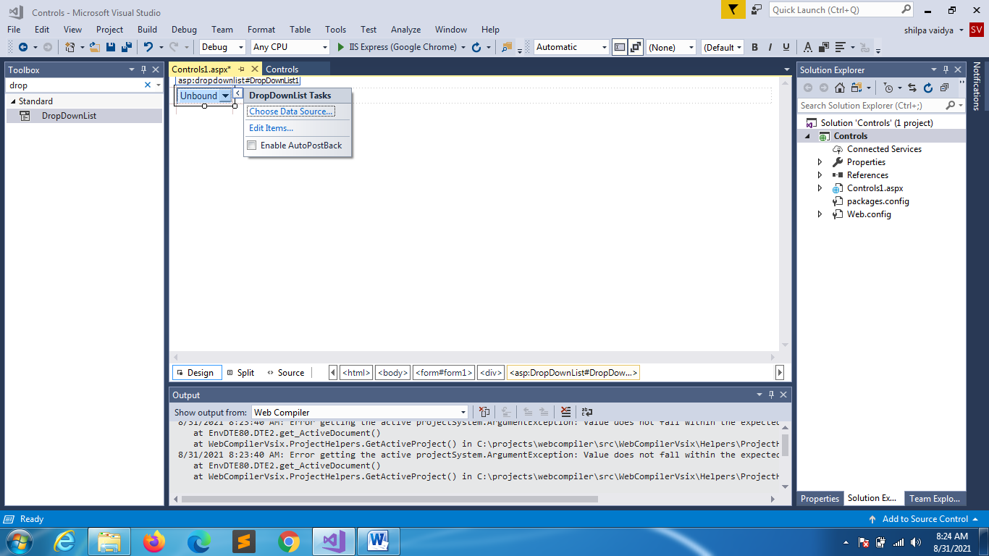

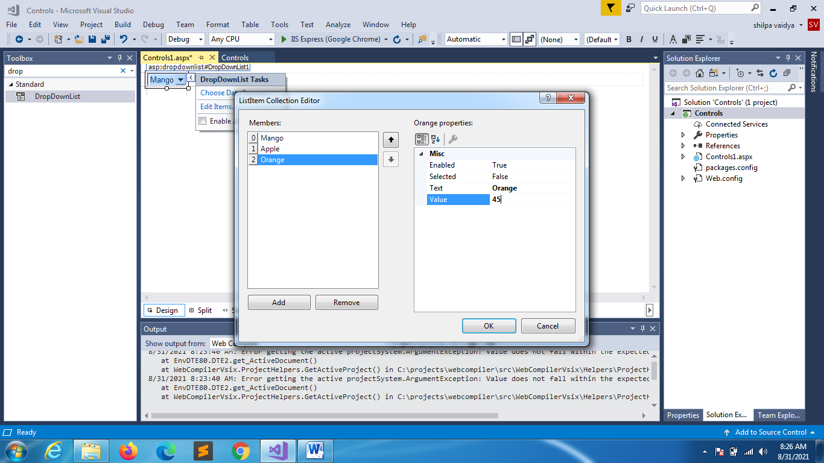

using System;

using System.Collections.Generic;

using System.Linq;

using System.Web;

using System.Web.UI;

using System.Web.UI.WebControls;

namespace Controls

{

    public partial class Controls1 : System.Web.UI.Page

    {

        protected void Page_Load(object sender, EventArgs e)

        {

            if(!IsPostBack)

            {

                ListItem li= new ListItem("Grapes", "89");

                DropDownList1.Items.Add(li);

                DropDownList1.Items.Add(new ListItem("Jackfruit","99"));

                DropDownList1.Items.Add("Butterfruit");

                DropDownList1.Items.RemoveAt(0);

                DropDownList1.Items.Remove(li);

            }

        }

    }

}

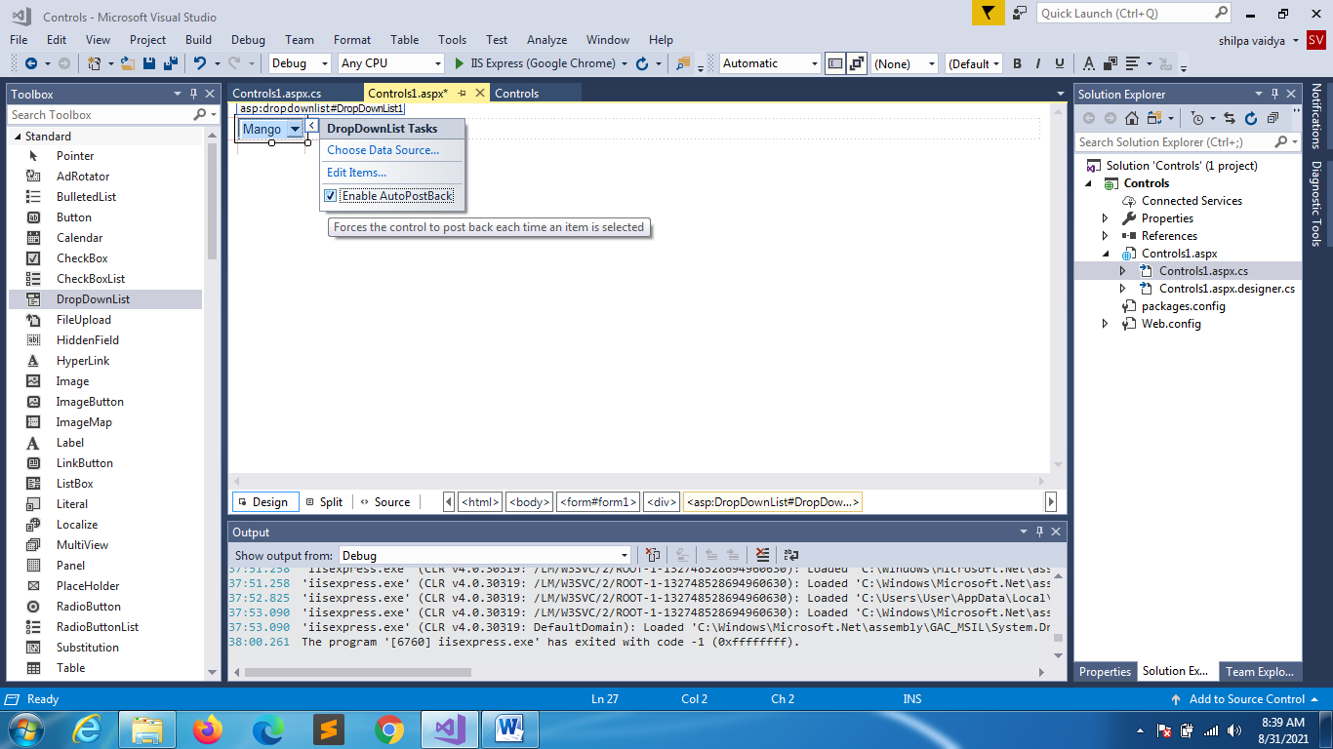

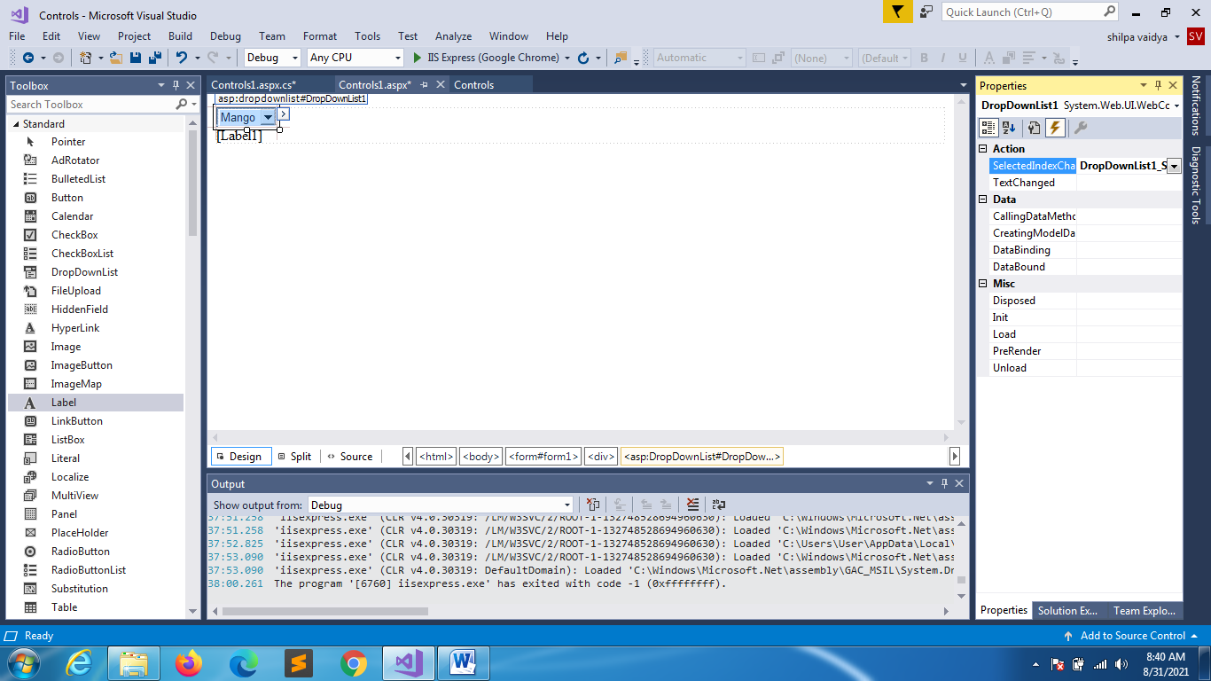

using System;

using System.Collections.Generic;

using System.Linq;

using System.Web;

using System.Web.UI;

using System.Web.UI.WebControls;

namespace Controls

{

    public partial class Controls1 : System.Web.UI.Page

    {

        protected void Page_Load(object sender, EventArgs e)

        {

            if(!IsPostBack)

            {

                ListItem li= new ListItem("Grapes", "89");

                DropDownList1.Items.Add(li);

                DropDownList1.Items.Add(new ListItem("Jackfruit","99"));

                DropDownList1.Items.Add("Butterfruit");

                DropDownList1.Items.RemoveAt(0);

                DropDownList1.Items.Remove(li);

            }

        }

        protected void DropDownList1_SelectedIndexChanged(object sender, EventArgs e)

        {

            Label1.Text = DropDownList1.SelectedItem + " : " + DropDownList1.SelectedValue;

        }

    }

}

LISTBOX

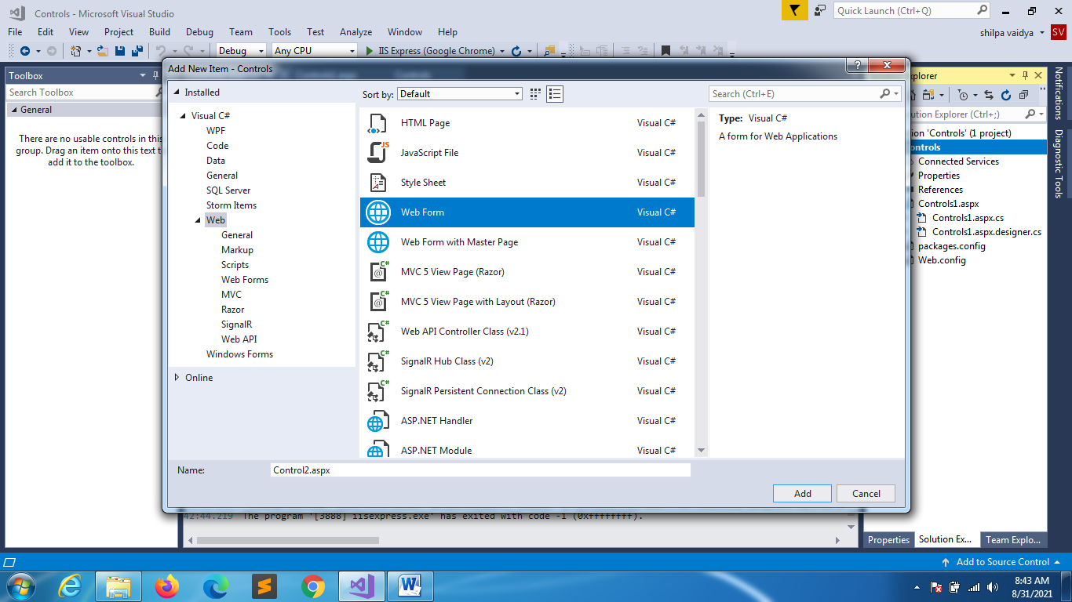

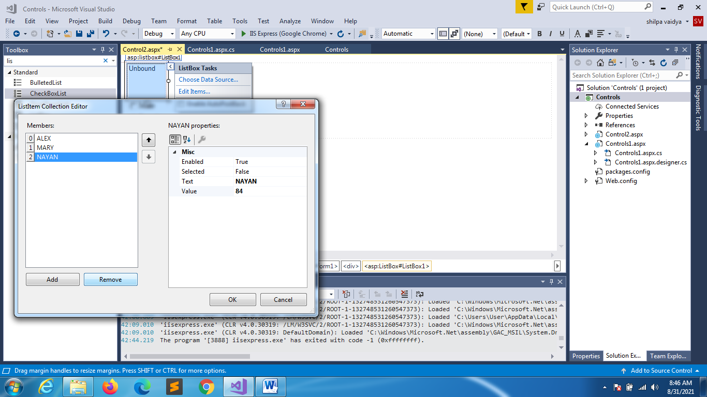

using System;

using System.Collections.Generic;

using System.Linq;

using System.Web;

using System.Web.UI;

using System.Web.UI.WebControls;

namespace Controls

{

    public partial class Control2 : System.Web.UI.Page

    {

        protected void Page_Load(object sender, EventArgs e)

        {

            if(!IsPostBack)

            {

                ListBox1.Items.Add(new ListItem("HARRY", "91"));

            }

        }

    }

}

CHECKBOX

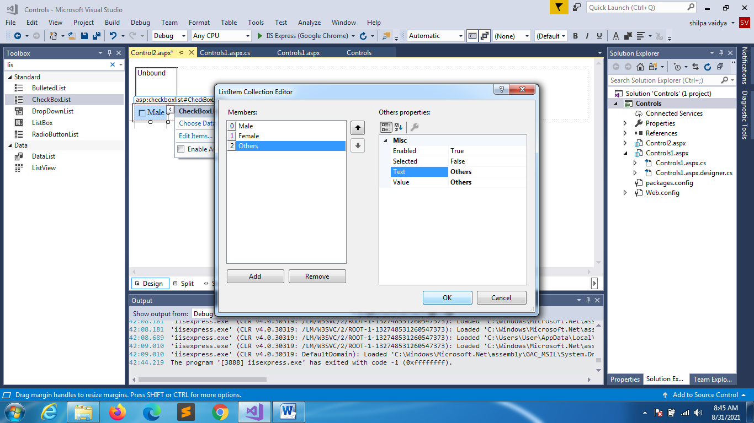

using System;

using System.Collections.Generic;

using System.Linq;

using System.Web;

using System.Web.UI;

using System.Web.UI.WebControls;

namespace Controls

{

    public partial class Control2 : System.Web.UI.Page

    {

        string selected = "";

        protected void Page_Load(object sender, EventArgs e)

        {

            if(!IsPostBack)

            {

                ListBox1.Items.Add(new ListItem("HARRY", "91"));

            }

        }

**protected void CheckBoxList1_SelectedIndexChanged(object sender, EventArgs e)**

**{**

**for(int i =0;i<CheckBoxList1.Items.Count;i++)**

**{**

**if (CheckBoxList1.Items[i].Selected)**

**selected += CheckBoxList1.Items[i].Text + "";**

**}**

**Label1.Text = selected;**

**}**

    }

}